## horizontal line



Pubdemy

v2

**─**

# Overview

**Pubdemy** is an Online Learning marketplace where students/professionals can buy courses and start using them. The courses bought are free for lifetime.

# Goals

1. Users are able to signup/signin the pubdemy.
2. After Sign up, the user should be able to login using the credentials mentioned.
3. After logging in, users should be able to search for courses (match title of the course).
4. Users can search the courses, add them to cart, view the summary, delete a course from cart and then finally checkout.

# Specifications

This project is created using the following specs and libraries :

* React (v18^)
* Redux Toolkit
* Bootstrap
* MongoDB
* React Hook Forms
* React Router DOM

The screens and goals are captured in snapshots.

**Login Screen**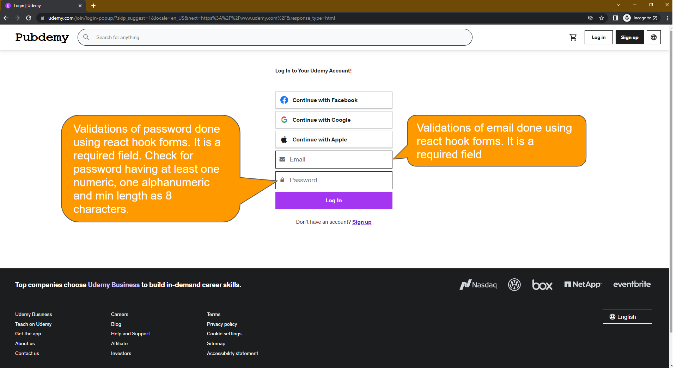

**Sign Up Screen**

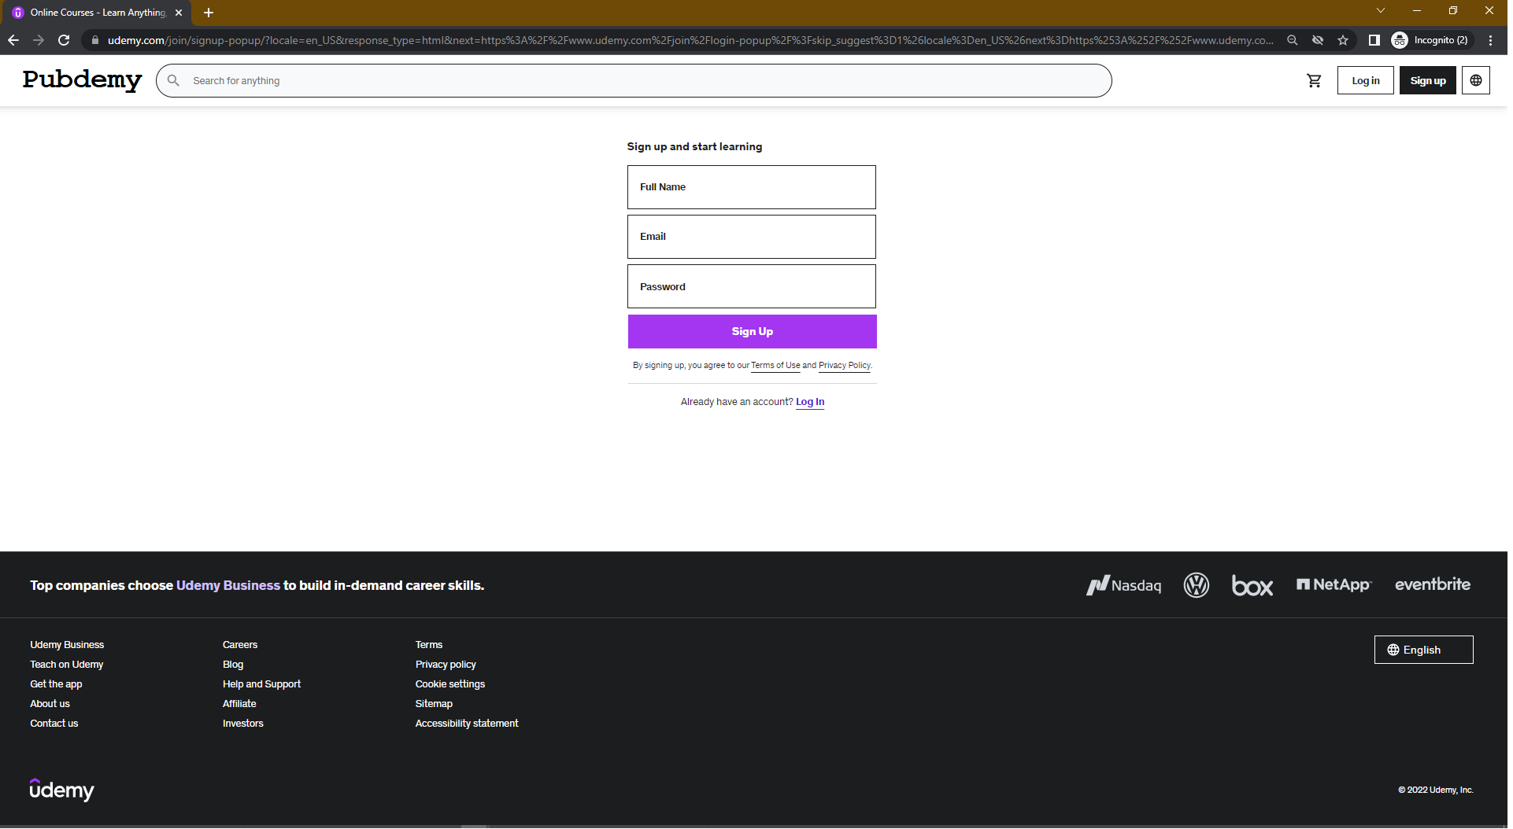

**Home Screen after login**

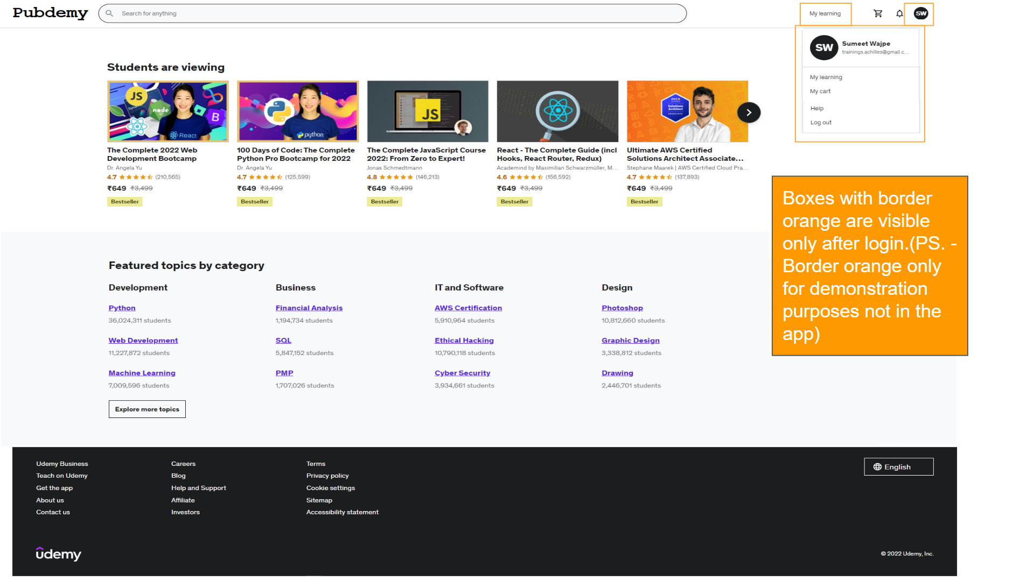

**Course Details Screen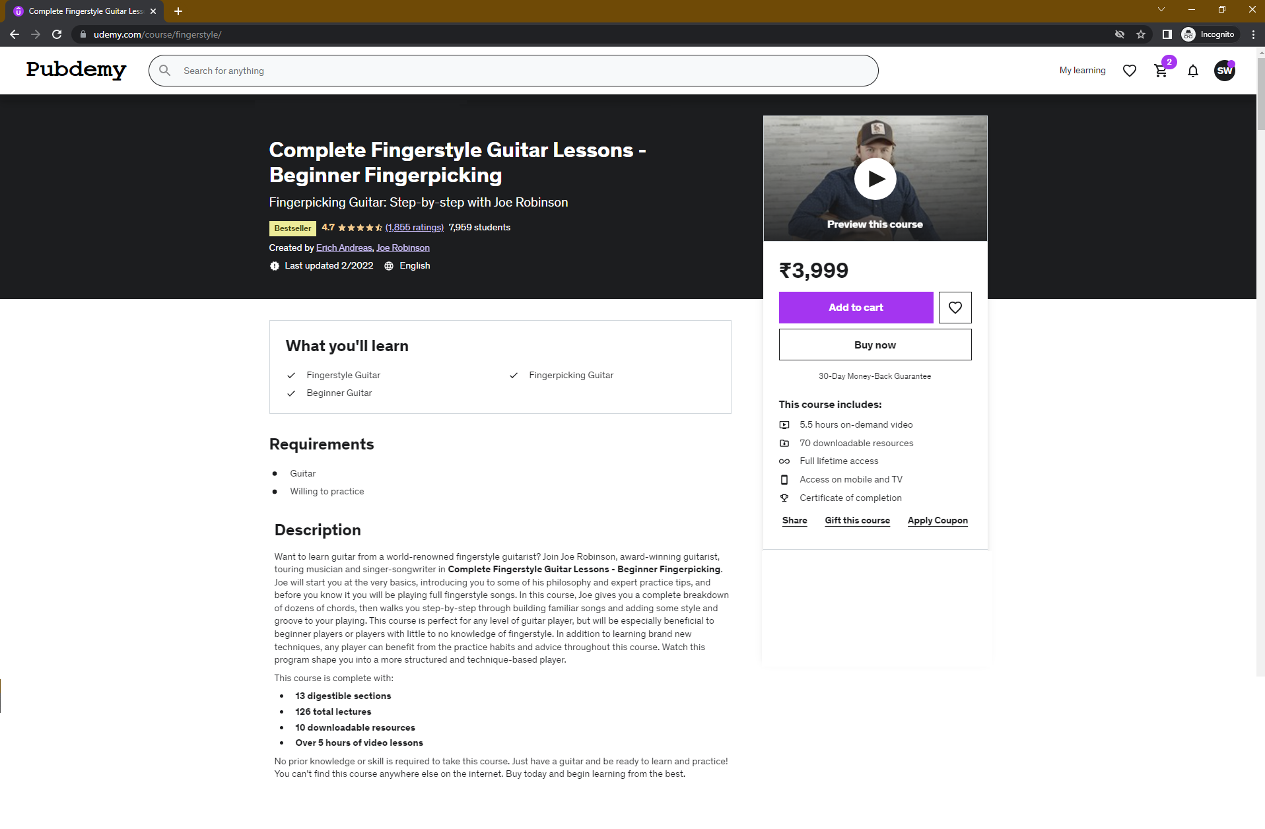Cart Summary Screen**

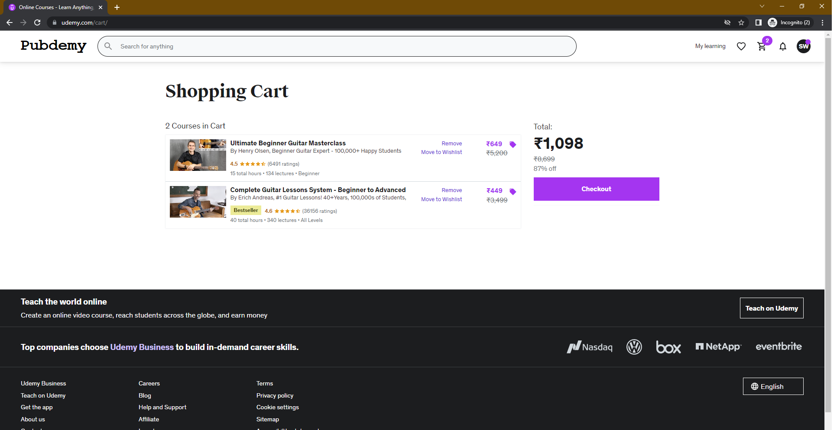

**Checkout Screen**

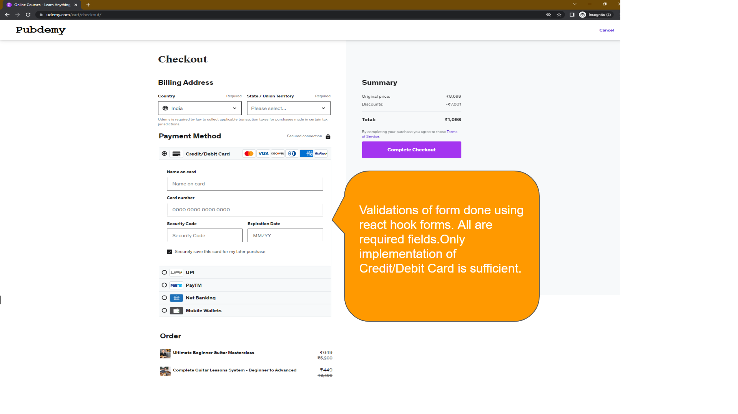

**Order Complete**

